**Relevance of the study of the cost of creating one workplace in Ukraine in the post-war period**

The ongoing full-scale Russian invasion has presented Ukraine with significant macroeconomic challenges, exacerbating the country's already struggling economy. By the start of 2023, the National Bank of Ukraine had reported a staggering 2.0 million individuals unemployed within Ukraine. Moreover, the conflict has forced nearly 5 million people to seek refuge in Europe and other countries, while over a million others have been drafted into the military. As the war eventually comes to an end, a considerable portion of the Ukrainian population may find themselves at risk of long-term unemployment, which poses a critical social issue that demands immediate attention, robust investments, and innovative policies.

To address this pressing concern, it is imperative to thoroughly investigate the cost of creating new workplaces in Ukraine during the post-war period. Such an investigation has not yet been conducted, despite its relevance in understanding the scale of investments required to foster healthy employment rates. Incorporating this issue into Ukraine's recovery plan is essential, as it will provide a framework for implementing effective strategies to generate sustainable employment opportunities.

Estimating the necessary investments needed to rejuvenate the job market will prove invaluable to the Ministry of Finance, enabling them to project and allocate appropriate expenditures in the national budget. By determining the financial resources required to create a robust and diverse range of workplaces, the Ministry can better strategize and allocate funds to support job creation initiatives. This will not only facilitate the reintegration of the population into the labor market but also stimulate economic growth and stability in the long run.

It is worth considering that the study of the cost of creating a workplace in Ukraine should encompass various aspects bey ond mere financial investment. Factors such as infrastructure development, vocational training programs, entrepreneurship support, and regulatory reforms should also be taken into account. By taking a holistic approach, policymakers and stakeholders can develop comprehensive strategies that address the multifaceted challenges hindering employment opportunities in the aftermath of the war.

Ultimately, a thorough investigation into the cost of creating workplaces in post-war Ukraine is vital for formulating effective policies and securing the necessary investments to achieve healthy unemployment. By integrating this research into Ukraine's recovery plan, the government can provide the framework and financial support needed to revitalize the job market, promote social stability, and foster sustainable economic development.

**Goal of research**

The target of the article to explore how many investments should Ukraine spend to return to pre-war unemployment rate.

**Literature review**

According to different economic theories, the relationship between gross capital formation (formerly gross domestic investment) and unemployment can be understood in various ways.

1. Classical Theory: The classical economists argue that any disturbances in an economy, including high unemployment or stagnant economic growth, will automatically correct themselves in the long run ([Edwards 1959](https://www.mdpi.com/2227-7099/8/2/26" \l "B12-economies-08-00026)). They believe that unemployment will disappear without the need for specific policy interventions.
2. Keynesian Theory: The Keynesian theory holds that unemployment is primarily caused by a lack of aggregate demand in the economy ([Keynes 1936](https://www.mdpi.com/2227-7099/8/2/26" \l "B17-economies-08-00026)). According to this view, authorities should implement appropriate policies such as expansionary fiscal or monetary measures to address unemployment and stimulate economic growth. Keynesian economists argue that unemployment results from inadequate policies, changes in economic structures, and a lack of education that aligns with labor market needs.
3. Balance Theory of Capital Formation: The balance theory of capital formation is particularly relevant for developing countries with lower economic growth rates and higher population sizes. This theory suggests that the government should invest in industrial capital goods across various sectors to achieve balanced employment growth ([Krishna and Perez 2005](https://www.mdpi.com/2227-7099/8/2/26" \l "B19-economies-08-00026)). By spreading capital goods throughout the economy, employment opportunities can be created in multiple sectors, leading to improved economic growth and a decrease in the unemployment rate.

**Theoretical concept**

Research is based on the New Keynesian framework about economics. The New Keynesian framework provides a comprehensive and coherent framework for analyzing macroeconomic fluctuations, understanding the role of policy interventions, and guiding policy decisions to stabilize the economy.

According to the Keynesian framework, changes in unemployment are primarily driven by fluctuations in aggregate demand. When aggregate demand is low, there is a surplus of goods and services, which leads to a decrease in prices, reduced output, and layoffs, increasing unemployment. Conversely, when aggregate demand is high, there is a shortage of goods and services, which leads to an increase in prices, increased output, and hiring, decreasing unemployment. The Keynesian model argues that government intervention can be used to stimulate aggregate demand and reduce unemployment.

[Unemployment in an Estimated New Keynesian Model: NBER Macroeconomics Annual: Vol 26 (uchicago.edu)](https://www.journals.uchicago.edu/doi/full/10.1086/663994)

[New Keynesian economics - Wikipedia](https://en.wikipedia.org/wiki/New_Keynesian_economics)

**Model**

Based on theory, our basic unemployment model will look like this:

(1)

where is unemployment rate, ADPW is aggregate demand for one worker.

The aggregate demand (AD) represents the total amount of goods and services demanded in an economy at a given price level. It is usually expressed as:

AD = C + I + G + (X - M), (2)

where:

* C represents consumer spending, which includes household consumption expenditures on goods and services.
* I represents investment, which includes business investment in capital goods, such as machinery and equipment, and residential investment, such as housing.
* G represents government spending, which includes government expenditures on goods and services.
* X represents exports, which are the goods and services produced domestically and sold to other countries.
* M represents imports, which are the goods and services produced in other countries and purchased domestically.

The (X - M) term in the formula represents the net exports.

Aggregate demand for one able-bodied person calculation formula is:

(3)

where AD is aggregate demand, TLF is number of total labor force in a country.

ADPW will help control for abrupt changes in number of labor force. It is easier to understand on example. For instance, Ukraine in 2023 has 10 million workers and 5 million able-bodied persons as refugees and aggregate demand X. ADPW will be . We assume that after the war refugees will return home. In short-run they will not be able to significantly increase aggregate demand, because there will be no work places in the country, so refugees will not be able to work. ADPW will be . Therefore, our model will show higher unemployment rate.

We don’t take into account non-working people, because Ukraine has solidary pension system. It means that Ukrainian government redirects a part of income from working people towards non working people. Therefore, aggregate demand is generated predominantly by working people.

Imagine that we have bare AD. After returning of refugees, AD will not change by assumption and overall input data will not change. Therefore, model will show same unemployment rate as before returning refugees.

From the structure of model and structure of AD, we can understand the relationship between investments and unemployment rate. Change the investments, it is possible to manipulate unemployment rate.

**Method**

We stopped at Tobit regression for our investigation, because UR has range (0, y*).

We considered also ARIMAX model, but we faced with non-stationarity of data.

Model (1) under OLS will look like this:

(4)

where interception, elasticity of aggregate demand per unemployed person.

There is a disadvantage of Tobit model, that we are only able to interpret coefficient via marginal effect in certain point.

**Assumption**

The main assumption is that the fluctuations in aggregate demand will cause inverse fluctuations in unemployment for countries.

On practice, it means that coefficient in (4) is expected to have negative sign.

**Data**

Model was evaluated using World Bank data. Except Ukraine, Poland and Romania were taken as candidates to check the assumption.

Indicators for which datasets were taken:

* Consumer spending (C) (in constant 2015 US dollars)
* Investment (I) (in constant 2015 US dollars)

In World Bank investment variable is called gross capital formation. is Gross capital formation consists of outlays on additions to the fixed assets of the economy plus net changes in the level of inventories. Fixed assets include land improvements (fences, ditches, drains, and so on); plant, machinery, and equipment purchases; and the construction of roads, railways, and the like, including schools, offices, hospitals, private residential dwellings, and commercial and industrial buildings. Inventories are stocks of goods held by firms to meet temporary or unexpected fluctuations in production or sales, and "work in progress." According to the 2008 SNA, net acquisitions of valuables are also considered capital formation.

* Government spending (G) (in constant 2015 US dollars)

In World Bank government spending variable is called general government final consumption. General government final consumption expenditure (formerly general government consumption) includes all government current expenditures for purchases of goods and services (including compensation of employees). It also includes most expenditures on national defense and security, but excludes government military expenditures that are part of government capital formation.

* Net export (X-M) (in constant 2015 US dollars)
* Total labor force (TLF)
* Unemployment rate (U) (in percentages)

**After-war unemployment forecast issues**

We have all the information to estimate pre-war model of unemployment, but there are few challenges with war and after-war unemployment forecast.

The two main issues is to forecast unemployment rate in absence of input data for 2022-2023 and that model does not take into the account the losses and destructions caused by the war.

The possible solution of the first problem is to imply some assumptions about state of aggregate demand in 2022-2023.

The second problem requires the additional adjustments of model. Therefore, we will use the model just for modeling of unemployment rate changes caused by recession.

Other problem arises from forecasting changes in the next period aggregate demand caused by investments in previous period.

**Performance in R**

**Data analysis and visualization**

Correlations between unemployment rate and ADPW for countries:

* Ukraine

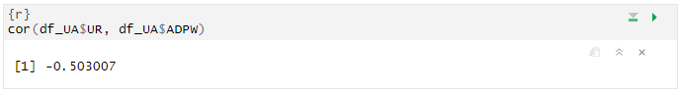

* Poland

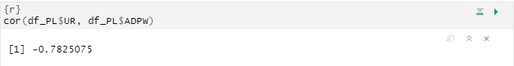

* Romania

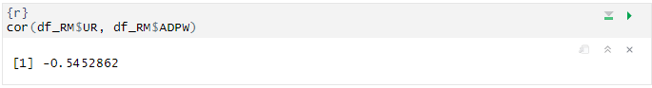

Ukraine and Romania have moderate correlation between ADPW and UR.

Poland has strong correlation between ADPW and UR.

Data visualization:

* Ukraine

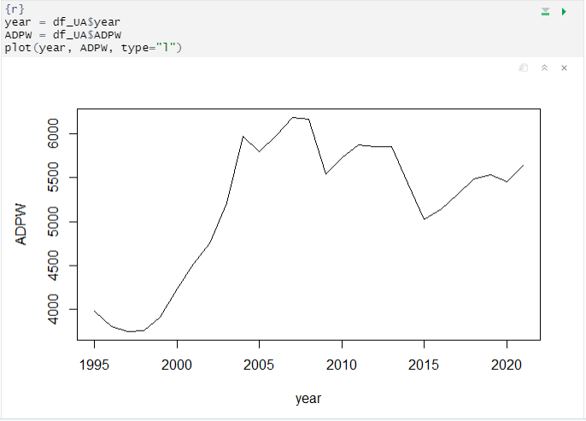

Ukrainian ADPW tended to increase from 1995 to 2005 years. Then it started stagnating. ADPW has not gone higher than 6183$.

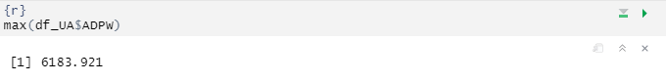

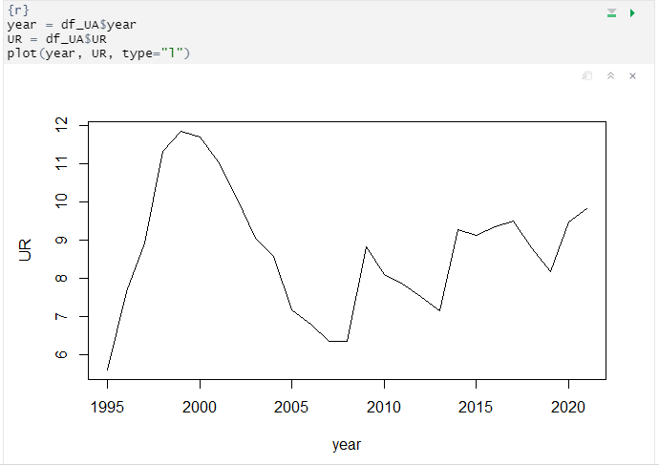

Ukrainian UR tends to fluctuate around the mean:

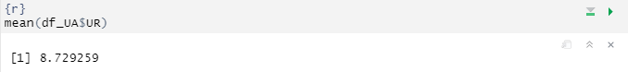

Starting from 1995, it has not gone below the 6% level.

* Poland

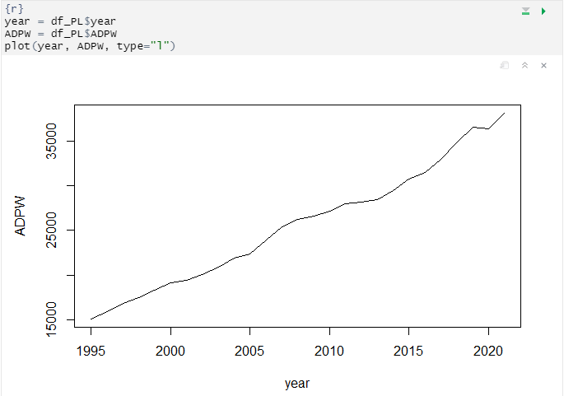

Polish ADPW shows constant growth starting from 1995. It reached the peak (38141 $) in 2021.

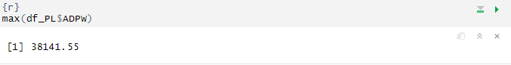

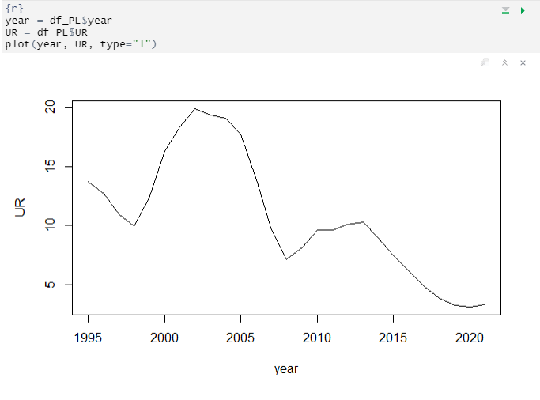

Poland had huge unemployment rate until 2007. In the last decade it tends to decrease and reached the minimum 3.16 % in 2020.

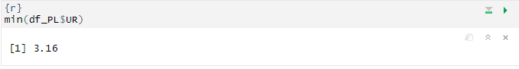

* Romania

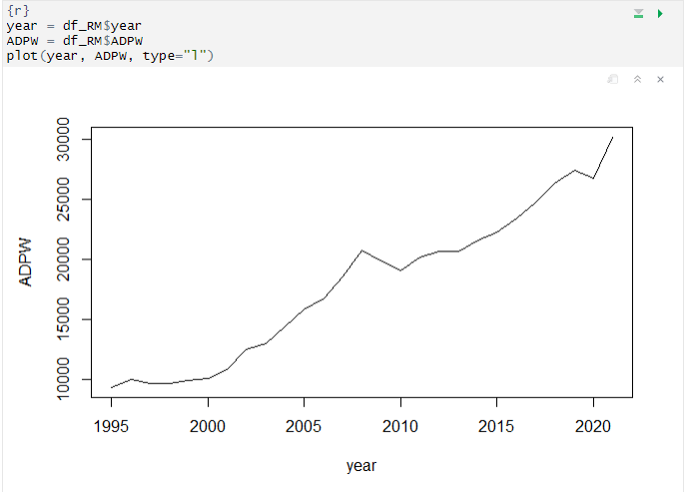

Romania, as Poland, shows constant APW growth starting from 1995. It reached the peak (30152 $) in 2021.

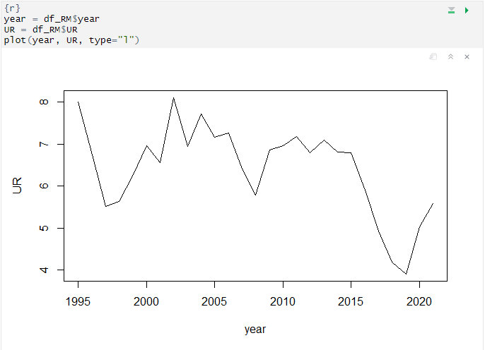

Romanian unemployment rate was fluctuating around 6,5% until 2015. Then it showed the decreasing trend.

**Test the assumption**

* Ukraine

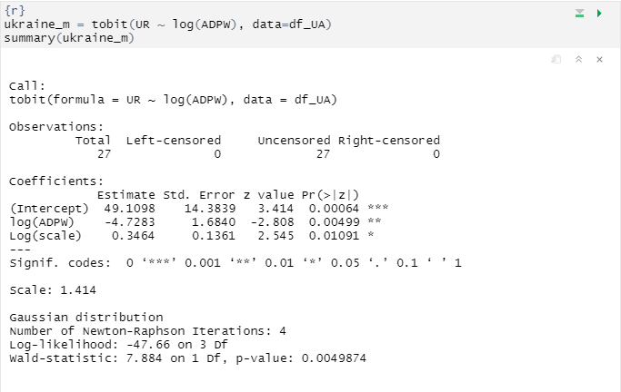

Coefficient on log(ADPW) is statistically significant on 1% level and has negative sign. Sign is expected according to New Keynesian framework. We can’t interpret the coefficient on log(ADPW), because we used Tobit model.

* Poland

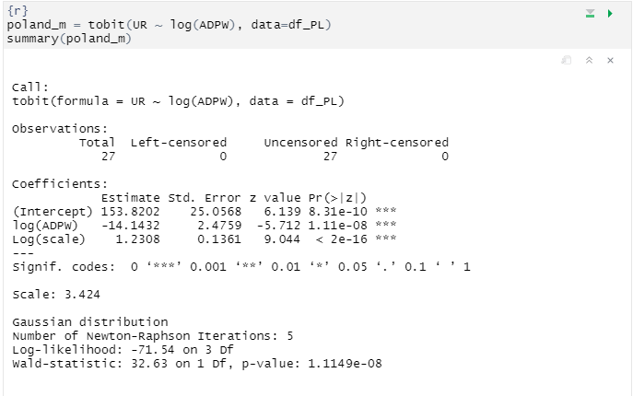

Coefficient on log(ADPW) is statistically significant on 0.1% level and has negative sign. Sign is expected according to New Keynesian framework. We can’t interpret the coefficient on log(ADPW), because we used Tobit model.

* Romania

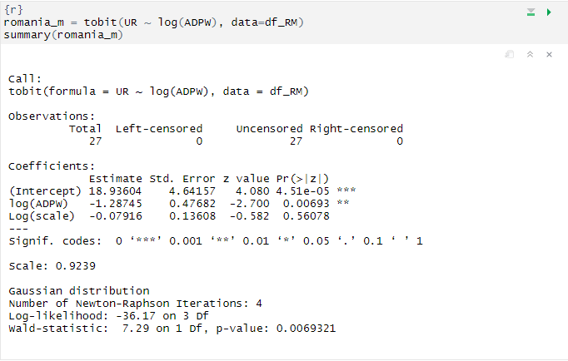

Coefficient on log(ADPW) is statistically significant on 1% level and has negative sign. Sign is expected according to New Keynesian framework. We can’t interpret the coefficient on log(ADPW), because we used Tobit model.

Generally, all the coefficients are statistically significant and have expected sign. It allows to say that there is an empirical evidence of New Keynesian framework. Increasing in aggregate demand leads to decreasing of unemployment rate.

Therefore, the model is valid instrument and can be used for forecasting.

**How the model works in war?**

It is important to compare the predicted unemployment rate of our model with the actual unemployment rate during wartime. These results will demonstrate the relevance of the model in accurately predicting unemployment during times of crisis.

As it was mentioned earlier, we should deal with some issues modeling UR during the war.

* Absence of data

The model requires only one input variable, denoted as ADPW. However, this variable is the result of dividing two economic variables, namely AD and TLF.

Let’s consider these variables separately.

We can make several assumptions about AD state during the war:

1. We can assume that the aggregate demand (AD) in 2022 decreased similarly to the decrease of AD observed in 2020, with an additional 30% recession. 2020 was chosen as the base year because it marked the beginning of the COVID-19 pandemic, which caused huge economic shock, especially in AD.
2. To estimate the AD for 2023, we can take the AD of 2022 and multiply it by the expected growth in 2023 of 3%.

We can estimate TLF similarly subtracting number of workable refugees. We assume number of labor force the same for 2022 and 2023 years.

* War externalities

Our model directly does not take into the account all war externalities that can cause the deviation of modeled UR from actual UR. Such externalities are hard to capture, especially in case of absence of any economic data.

**Estimation of TLF**

Since February 24, 2022, when the large-scale Russo-Ukrainian war began, 9.3 million people have left Ukraine. However, 7.4 million Ukrainians have managed to return home. Currently, there are 2.1 million Ukrainian citizens abroad.

In total, the proportion of children under 16 and adults over 60 in Ukraine is 37%, while the percentage of working-age adults is 63%. Let's assume that the same proportion applies among refugees, so the number of working-age refugees is:

<https://zakordon.24tv.ua/skilki-ukrayinskih-bizhentsiv-perebuvaye-za-kordonom-svizhi-dani_n2184464>

Before the war, the number of working-age population was 20 285 701 individuals. If we subtract the number of refugees, the current working-age population stands at

We subtract working-age refuges and do not consider them while calculating UR, because they do not generate demand within Ukraine.

**Model predictions for war-time period (2022-2023)**

* 2022 year

AD in 2022 year:



TLF in Ukraine in 2022 year:



Predicted UR:

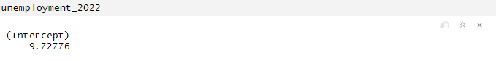

According to NBU [statistics](https://www.epravda.com.ua/rus/news/2023/01/17/696057/index.amp) in 2022 year, 3.2 million people searched for work within Ukraine. Unemployment rate without taking into the account refuges equals to:

%

Model prediction differs from real unemployment rate without taking into the account refuges on:

* 2023 year

AD in 2023 year:



TLF in Ukraine in 2022 year:



Predicted UR:

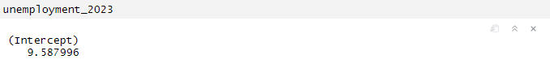

According to new NBU [statistics](https://www.epravda.com.ua/rus/news/2023/01/17/696057/index.amp) in 2023 year, 2.0 million people searched for work within Ukraine. Unemployment rate within the country equals to

Predicted and real value differs on:

**Analysis of results**

Analyzing the results, we can conclude that model failed to predict UR in 2022 year and successfully predicted UR for 2023 year.

The reason for this inaccuracy of prediction could be unaccounted war externalities, especially internal and external migration in 2022. Unstable front and hostilities in 2022 forced many people to migrate. They had to find new place of living in other regions. After stabilization of the front, people returned to their living places and were back to their old work places. This fact can explain huge difference (1.2 million people) between amount of people searching for the work in 2022 and 2023.

**How investment affects aggregate demand based on the Keynesian multiplier**

The Keynesian Multiplier is an economic concept that explains how changes in investment can influence aggregate demand. According to Keynesian economics, changes in aggregate demand, which is the total demand for goods and services in an economy, can have a significant impact on economic output and employment levels.

The Keynesian Multiplier suggests that an initial change in investment spending can have a multiplied effect on aggregate demand. When businesses increase their investment spending, such as by building new factories, purchasing equipment, or undertaking infrastructure projects, it stimulates economic activity and leads to increased production and income.

Here's how the Keynesian Multiplier works:

1. Initial Increase in Investment: Let's say there is an initial increase in investment spending by businesses. This could be due to factors such as improved business confidence, lower interest rates, or government incentives to encourage investment.
2. Increase in Aggregate Demand: The increased investment spending directly increases the demand for goods and services produced by other businesses. As a result, the businesses that supply these goods and services experience higher demand and, in turn, increase their production to meet the increased demand. This leads to an increase in aggregate demand in the economy.
3. Multiplier Effect: The increase in aggregate demand sets off a chain reaction. The businesses that receive the increased demand for their products and services, in turn, increase their spending, such as hiring more workers, increasing wages, and purchasing more inputs. This additional spending by businesses then becomes income for households and workers, who, in turn, increase their consumption and spending on goods and services. This process continues, with each round of increased spending leading to further increases in aggregate demand.
4. Total Impact on Aggregate Demand: The cumulative effect of this multiplier process is that the initial increase in investment spending has a multiplied impact on aggregate demand. The total increase in aggregate demand is larger than the initial increase in investment.

By influencing aggregate demand, changes in investment can have a significant impact on economic output, employment levels, and overall economic growth. In times of economic downturns, governments often use fiscal policies, such as increasing public investment, to stimulate the economy and boost aggregate demand through the Keynesian Multiplier effect.

[What Is the Multiplier Effect? Formula and Example (investopedia.com)](https://www.investopedia.com/terms/m/multipliereffect.asp)

**Calculation of impact of investments on aggregate demand**

Our method is based on Keynesian multiplier effect theory. To calculate the impact of investments on aggregate demand, we run linear regression AD in period on investments in period .

Regression formula for investments:

(5)

Correlation for between investments in the first period and aggregate demand in the second period for Ukraine:

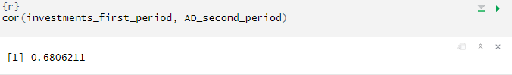

Correlation is medium.

Regression for AD:

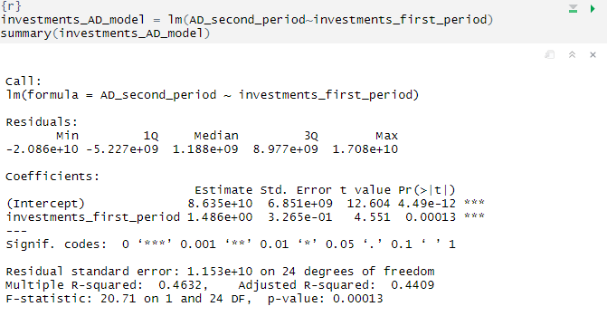

Coefficient on investments in the first period is statistically significant in 0,1%. We have strong evidence of effect of investments on aggregate demand.

Magnitude of coefficient is 1.486. It means that increasing of 1$ investments in the first period leads to increasing on 1.486$ in aggregate demand in the second period.

Residuals is normally distributed:

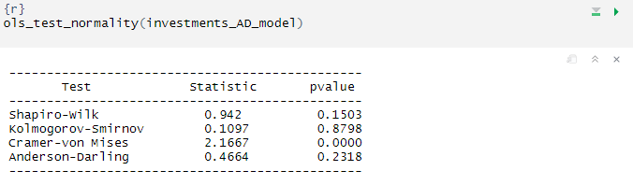

We can conclude that there is no bias in our regression.

We will this model further for calculation the effect of post-war investments on growth of aggregate demand.

**How many refugees are going to return?**

According to the [survey](https://www.bing.com/search?pglt=41&q=чи+планують+біженці+повертатись+в+україну&cvid=ef03f91662e54760873a77f4eb58a768&aqs=edge..69i57j0l8.13489j0j1&FORM=ANNTA1&PC=U531&ntref=1), 36% of Ukrainians (refugees) plan to return home, so out of 2 100 000 people, only 756 000 will return, of which 476 280 will be of working age. Therefore, after the war, the number of working-age population will be: